**ENGR 121 Homework 1**

**NOTE:** Use non-engineering format for all questions. This is an individual assignment.

1. 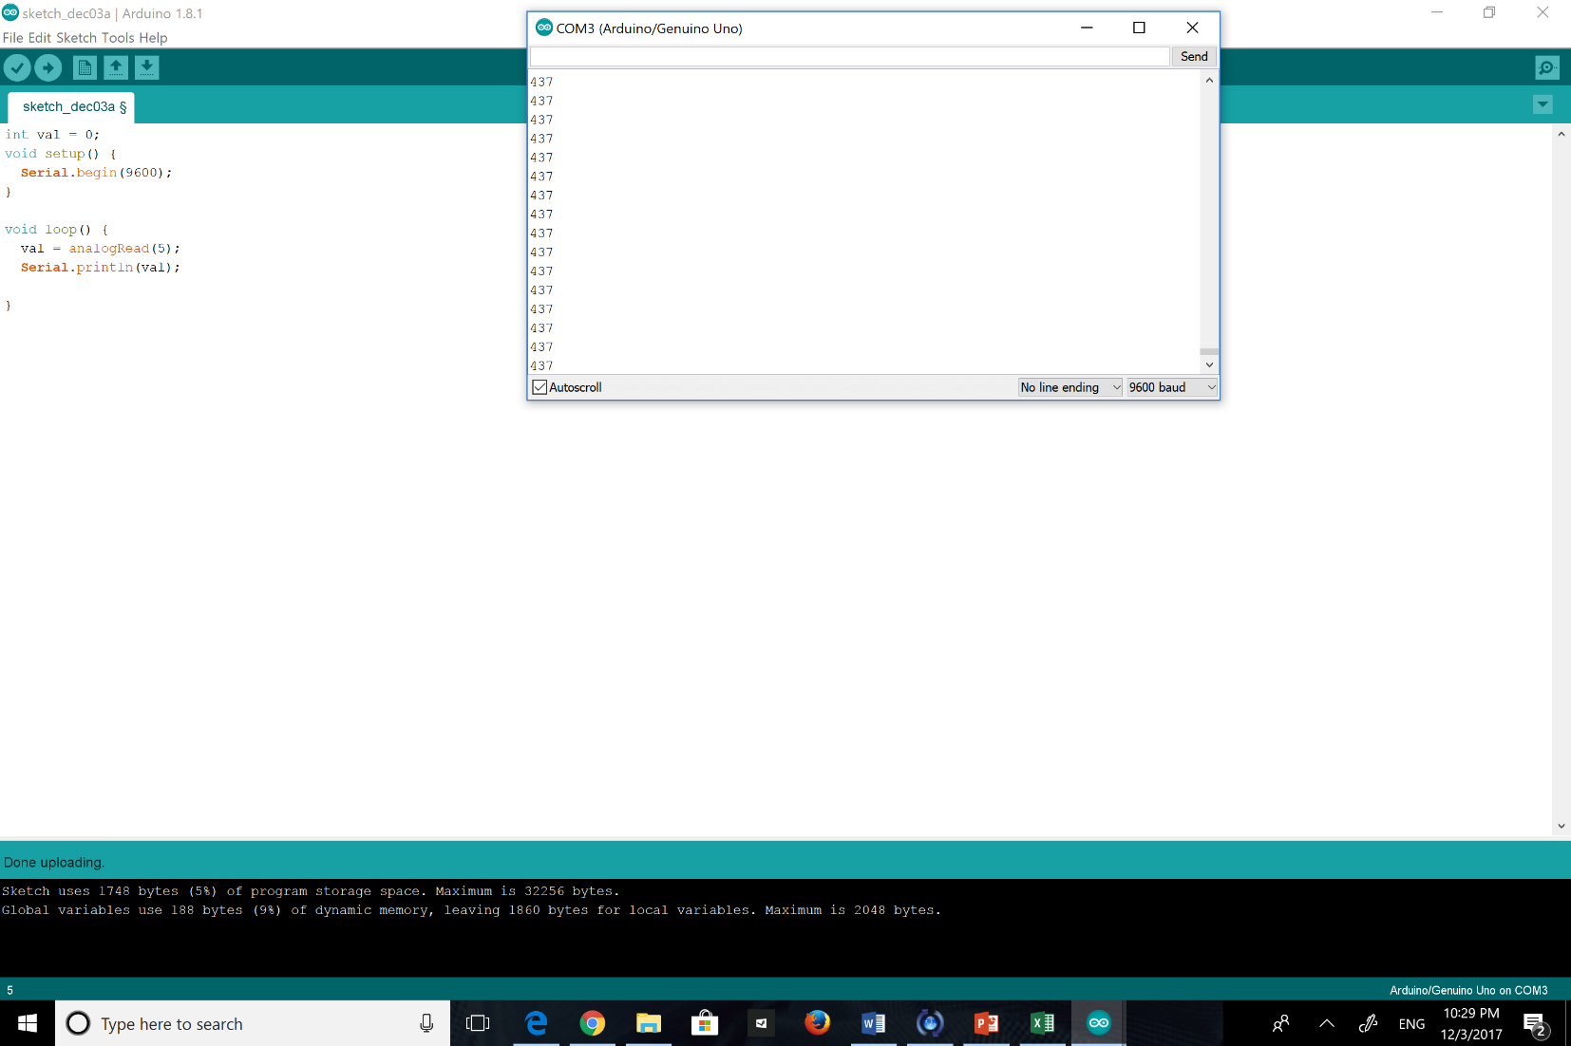Finish the thermistor programming activity from class. Print out the analog values as integers and the corresponding temperature values as decimals on the serial monitor. Provide a screen shot of your serial monitor.

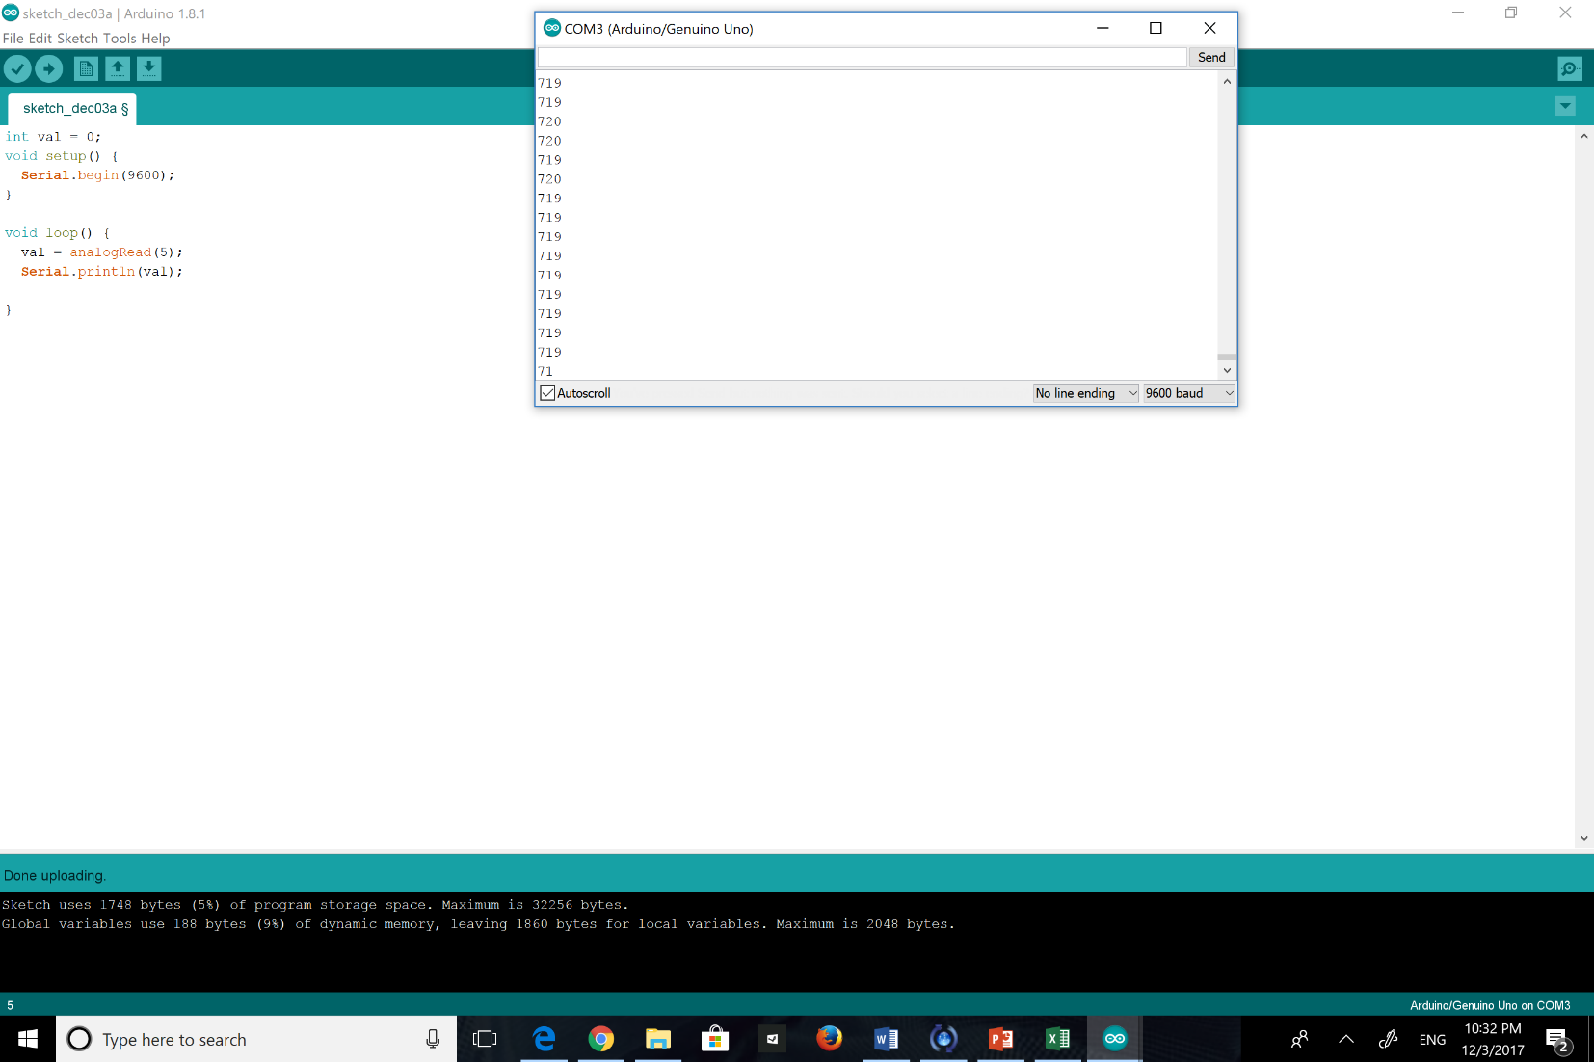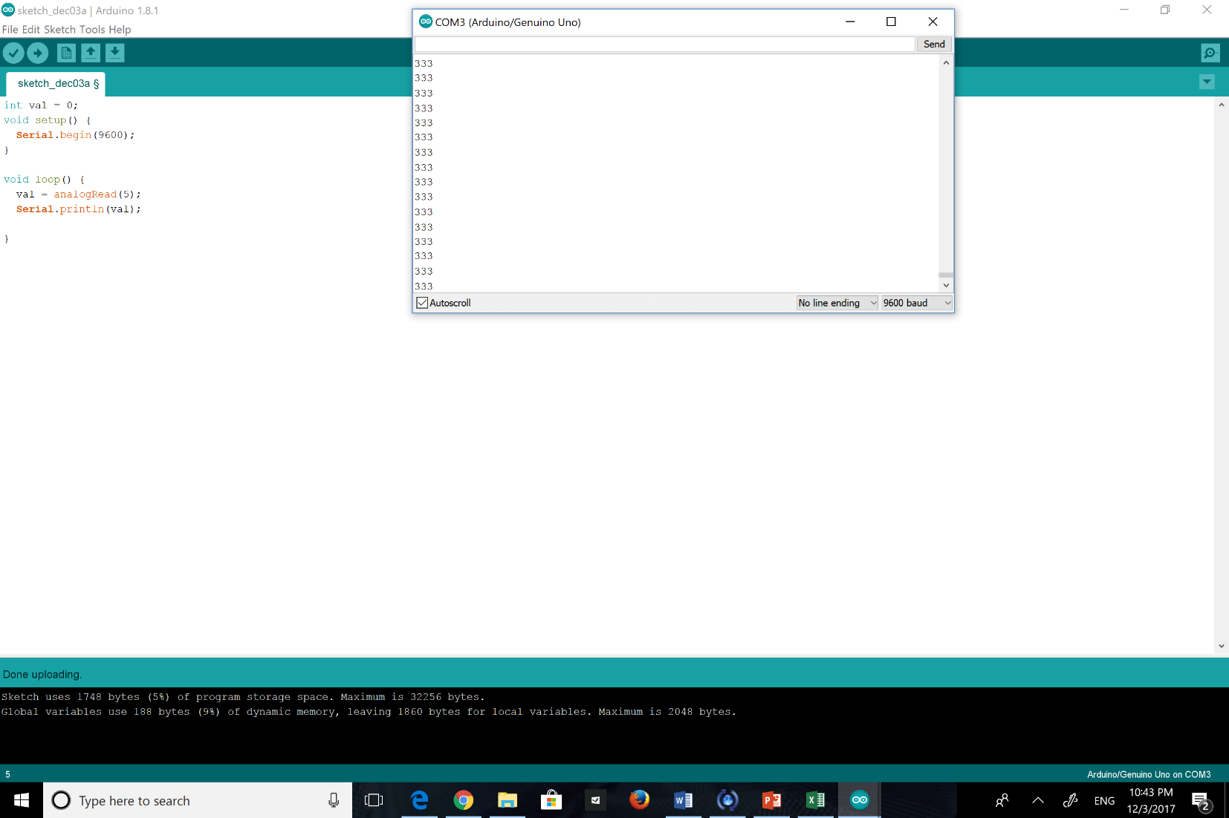

1. Turn in your calibration data and graph generated in class 1 (or completed since then). Provide both the calibration equation (analog value as a function of temperature) and its inverted form (temperature as a function of analog value). Be sure to use proper formatting for the raw data and the graph (units, axis labels, graph title, etc.).

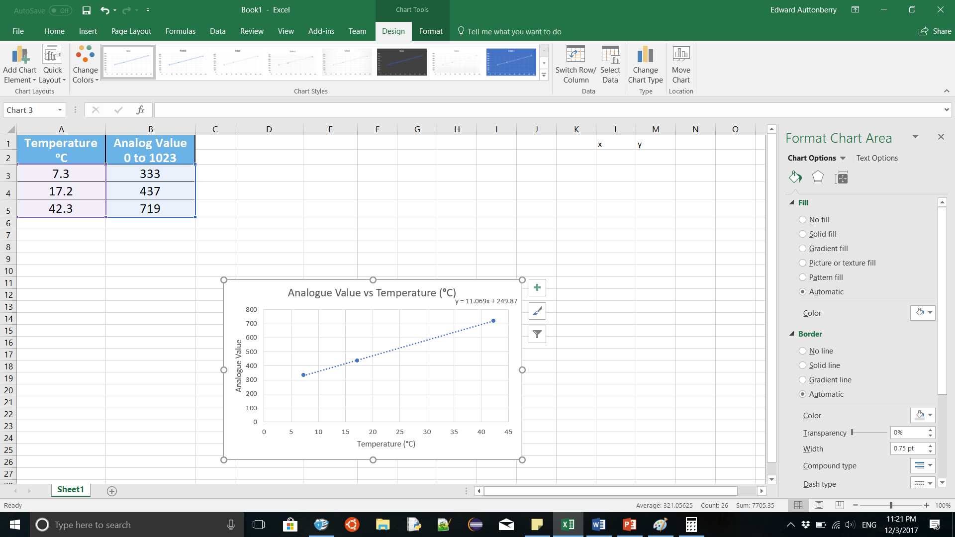

1. 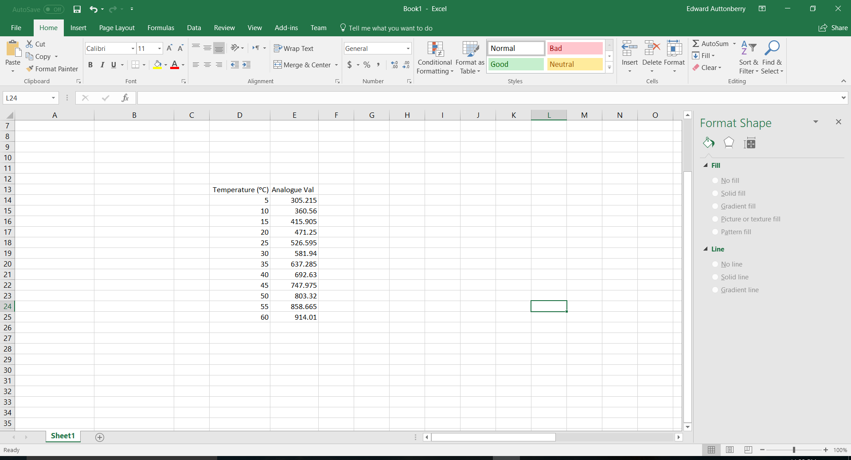Embed your initial calibration equation (analog value as a function of temperature) into an Excel spreadsheet to compute the analog value for any given temperature value. Choose numbers ranging from 5ᵒC to 60ᵒC in increments of 5ᵒC.

1. Embed your inverted equation from problem 2 (temperature as a function of analog value) into an Excel spreadsheet to compute the temperature for analog values ranging from 0 to 1023. Please use analog increments of 50, and also compute the final value at 1023.

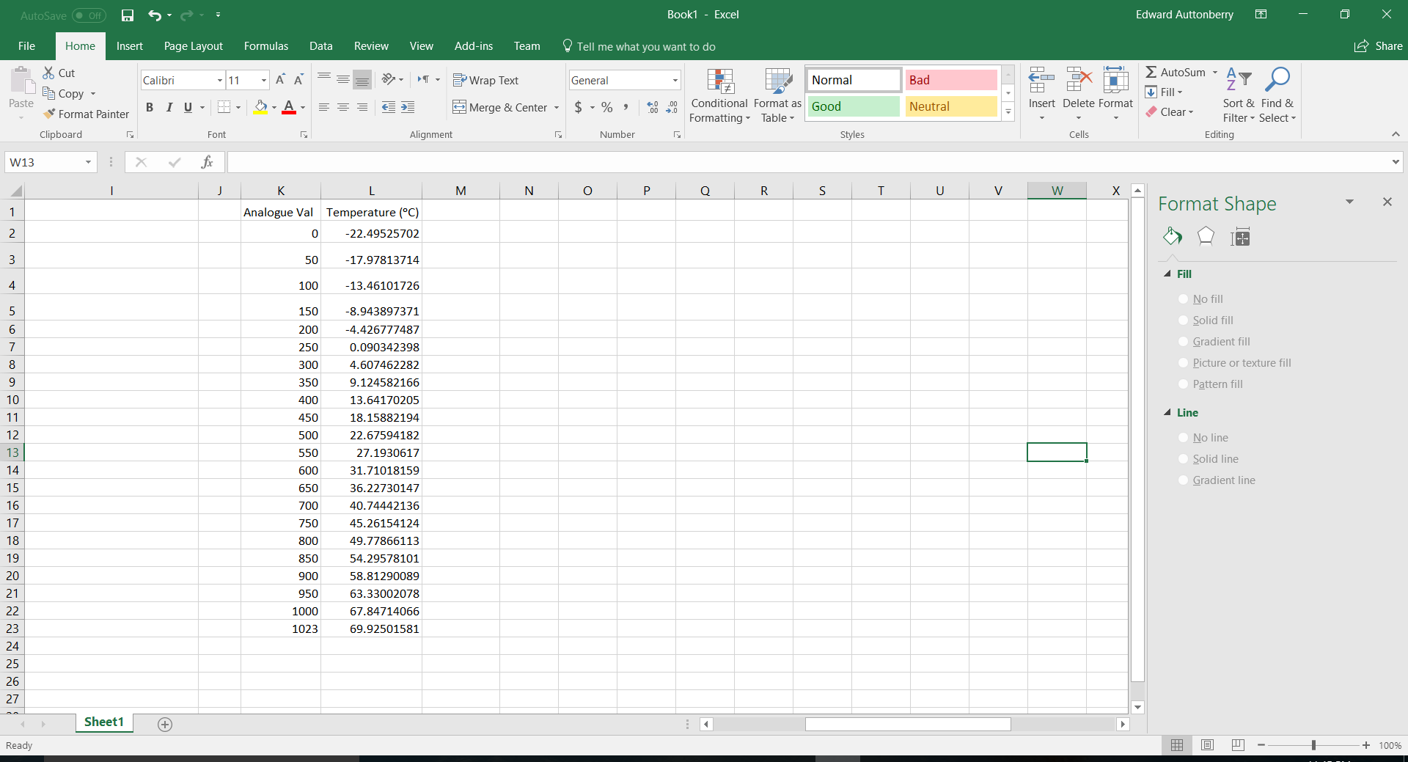

1. Research another temperature sensor (other than the thermistor). Write a few sentences describing how the sensor works, and include some advantages and disadvantages of the sensor.

**Thermometers works by Mercury. It moves depending on the temperature. Also, it is inexpensive and easy to use, but it has some disadvantage such as mercury vapor is poisonous.**

1. Find the ENGR 121 syllabus online. Provided the following information:
   1. Date, time, and location of Exam 1 **16/1/2018, CTLH 328**
   2. Date of final Temperature Control Check **22/1/2018**
   3. Date of final System Check (Conductivity Check) **18/2/2018**
   4. Date of Fishtank Presentation **31/1/2018**
   5. Date, time, and location of Exam 2 **22/2/2018, CTLH 328**
   6. Date of Quiz 1 **18/12/2017**
   7. Date of Quiz 2 **16/2/2018**
   8. Number of service hours you have to get this quarter? **5**
   9. Number of COES meetings you have to attended this quarter? **5**
   10. Your professor’s office location, office phone number, and email address **BH 212, 318/257-2157,** [**long@latech.edu**](mailto:long@latech.edu)
2. **(Due Class 3)** Please complete the Engineering Student Survey found on the META ENGR 121 Moodle page. **Done**